Testbench Type 1 - Gimbal Based (3DOF - roll, pitch, yaw)

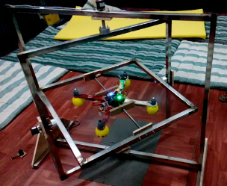

<https://youtu.be/_vgJEXKVzeo>

* Steel frame

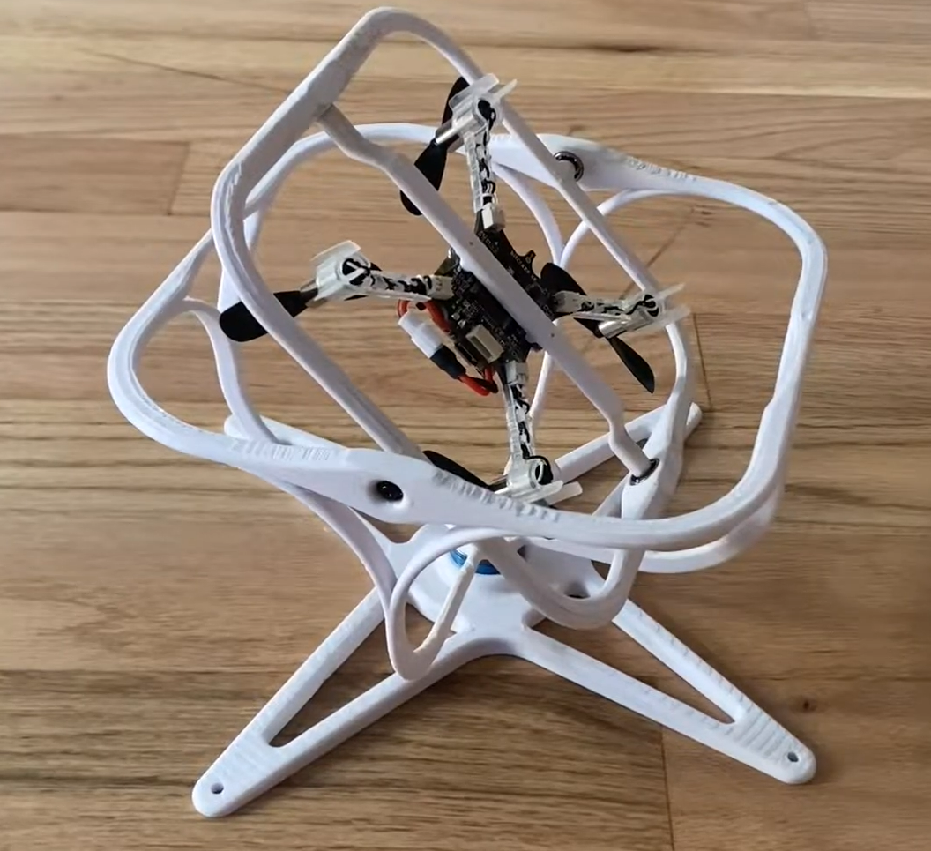

<https://youtu.be/hn7csjkalUQ>

* 3D printed

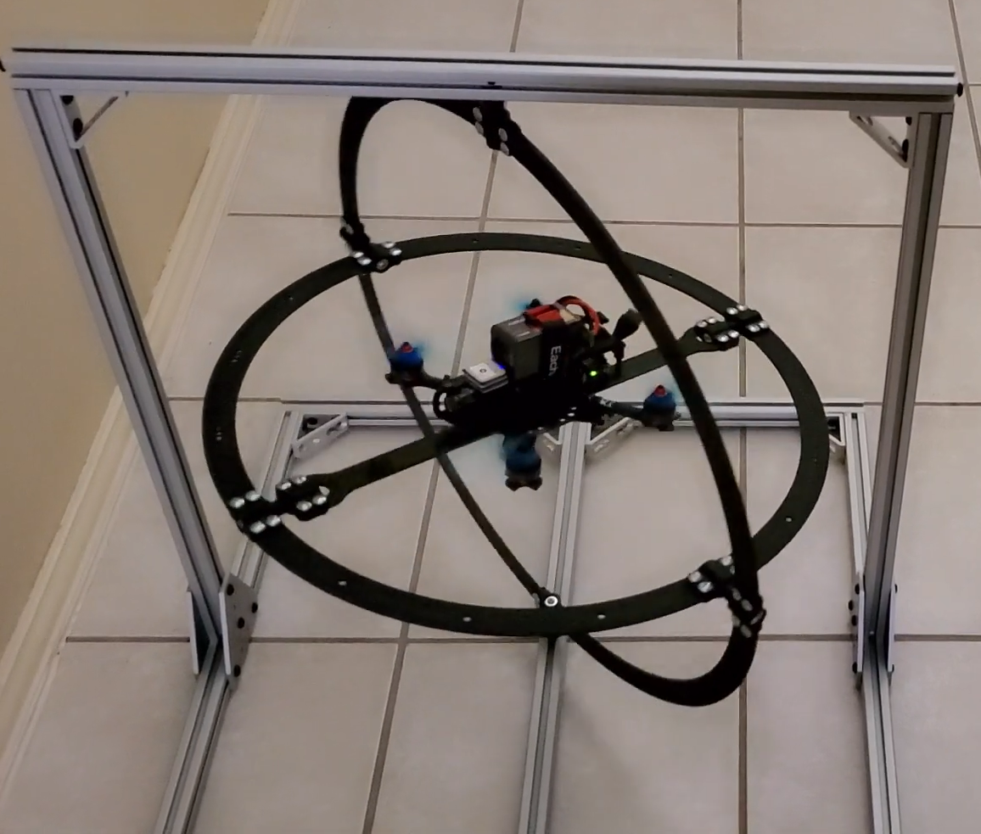

<https://youtu.be/44Q-32hcxdw>

* Aluminum Frame
* Ball Bearing Pivot Points
* Carbon Fiber Gimbal section for increased strength to weight

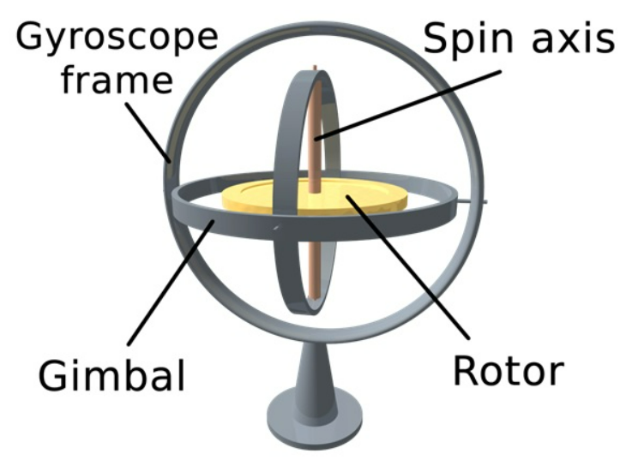

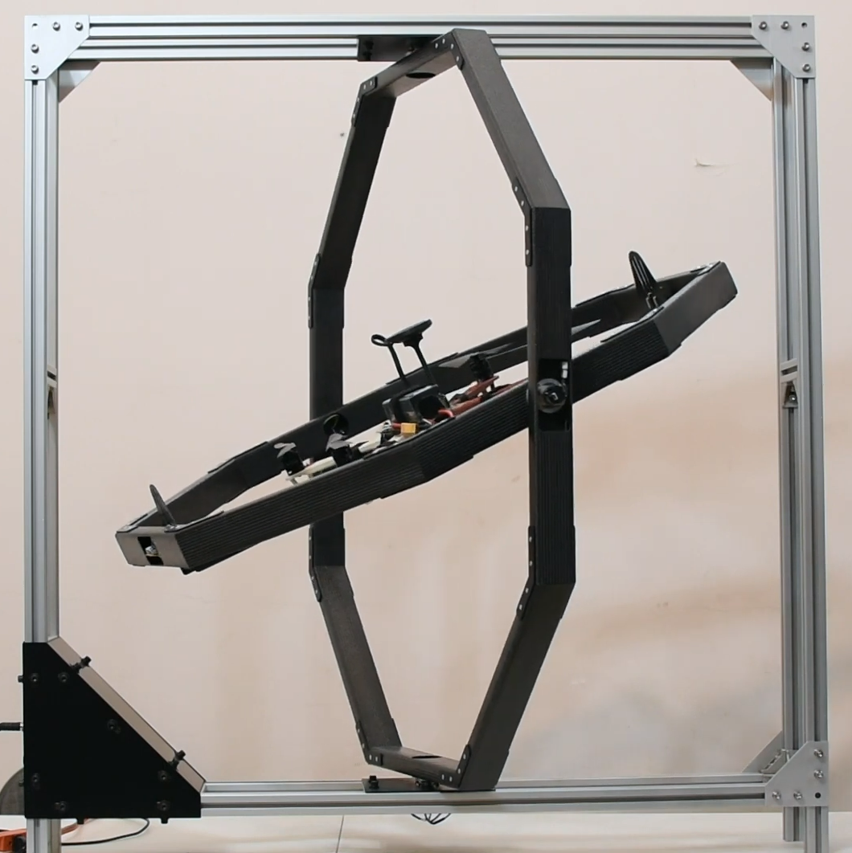

<https://youtu.be/n76H9Gta7Ok>

Testbench Type 2 - Stand with Ball head and linear bearing (4DOF - roll, pitch, yaw, height)

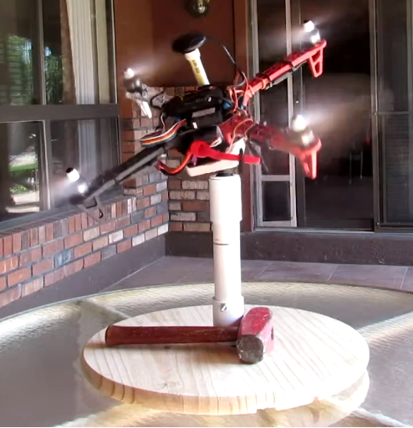

<https://youtu.be/p9n0MNw_Wms>

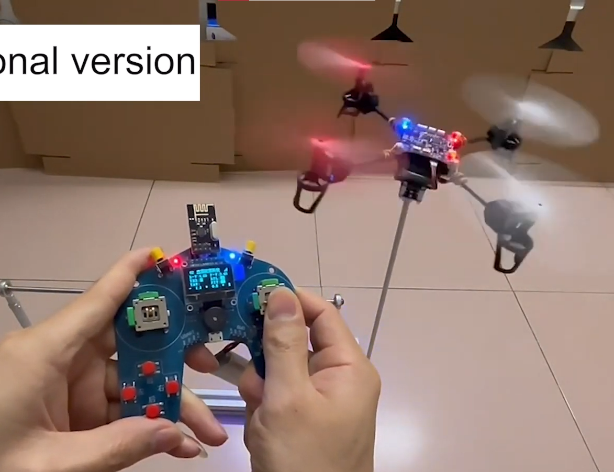

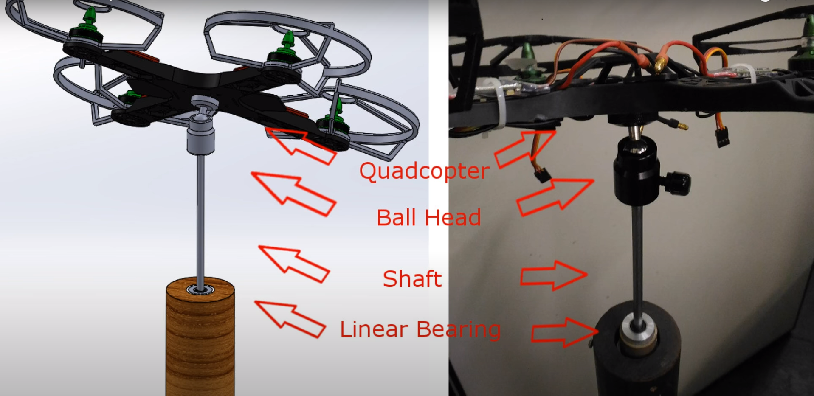

4 DOF Test Bench

<https://youtu.be/Nju5yUpFetU>

Research Paper DOI: 10.11606/D.3.2017.tde-23102017-144556

Link: <https://teses.usp.br/teses/disponiveis/3/3139/tde-23102017-144556/pt-br.php>

* Safe and functional 4 DOF quadcopter test-bench
* To develop and test different attitude and altitude controllers such as PID